Global Air Pollution

INN Manita
American University of Phnom Penh ITM 370 Section 001: Data Analytics

Global Air Pollution

Introduction:
- Objectives and purpose of the analysis.
+ Objective:
  - To develop a predictive framework that accurately estimates AQI using concentrations of pollutants (CO, Ozone, NO2, PM2.5).
  - To assess the effectiveness of different approaches in improving model accuracy and reliability
  - To provide insights that aid policymakers and environmental agencies in making informed decisions about air quality management.

+ Purpose:
The purpose of this analysis is to explore and quantify the relationships between four key air pollutants (CO, Ozone, NO2 and PM2.5) and the Air Quality Index (AQI) values provided in the dataset.

- Provide a brief overview of the dataset used.
The dataset provides information on air quality across various countries and cities, capturing different Air Quality Index (AQI) values for specific pollutants. Each record represents air quality measurement for a specific location, including details on major pollutants that impact public health. The dataset contains 23463 rows and 12 columns with 5 numeric columns and 7 categorical columns.

Key Columns and Description of the dataset:
  - Country: name of the country where the air quality measurement was recorded
  - City: name of the city where the data was collected
  - AQI Value: Overall AQI value of the city
  - AQI Category: Overall AQI category of the city Pollutant-Specific Data:

  - CO AQI Value: AQI value of Carbon Monoxide of the city
  - CO AQI Category: AQI category of Carbon Monoxide of the city
  - Ozone AQI Value : AQI value of Ozone of the city
  - Ozone AQI Category : AQI category of Ozone of the city
  - NO2 AQI Value : AQI value of Nitrogen Dioxide of the city
  - NO2 AQI Category : AQI category of Nitrogen Dioxide of the city
  - PM2.5 AQI Value : AQI value of Particulate Matter with a diameter of 2.5 micrometers or less of the city
  - PM2.5 AQI Category : AQI category of Particulate Matter with a diameter of 2.5 micrometers or less of the city

Data Preprocessing:
- The datasets has been thoroughly checked and confirmed to contain:
  - No duplicate rows
  - No duplicate columns
  - 427 missing values in the column “Country”
  - 1 missing values in the column “City”
  - None missing values for the rest of the columns
  - Outliers Identified in Numeric Columns Using the Interquartile Range (IQR):
. AQI Value: 2935
. CO AQI Value: 8596
. Ozone AQI Value: 1513
. NO2 AQI Value: 1681
. PM2.5 AQI Value: 2641
  - All entries in the categorical column have their initial letters capitalized, indicating consistent formatting without the need for further format cleansing.
  - The data was already in the right format with all columns having the right data types. As such, no additional transformations were required before using the data for the model.

- All missing values were handled by using the Replace method. A total of 428 missing values were found out of 23463 rows, representing approximately 1.8%. The decision
was made to replace these blank fields with “Unknown” to prevent biases and ensure the integrity of future work.

- Approach to handle outliers were handled:
All outliers have been retained in the dataset. By utilizing the count method to organize the unique values across AQI pollutant categories, we observed that while most values fall within the 'Good' range, instances exceeding 301 (the 'Hazardous' category) are rare. Removing these outliers could diminish our insights into the hazardous conditions of air quality. Therefore, retaining them ensures a comprehensive understanding of the dataset and highlights critical areas of concern regarding air pollution.

Below is the bar chart and table used to support our reasoning:

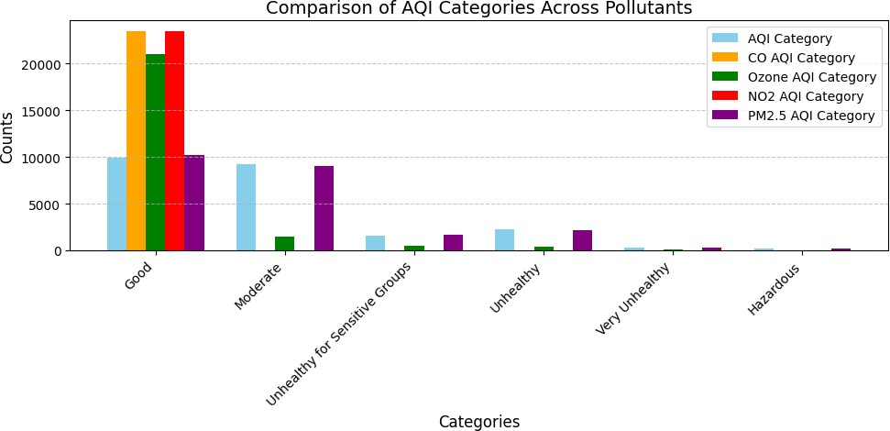

Specific Counts of each AQI category

 | AQI Value | CO AQI Value | Ozone AQI Value | NO2 AQI Value | PM2.5 AQI  Value

Good | 9936 | 23460 | 21069 | 23448 | 10208
Moderate | 9231 | 2 | 1445 | 15 | 9075
Unhealthy | 2227 | 1 | 491 | - | 2129
Unhealthy for Sensitive Groups | 1591 | - | 405 | - | 1624
Very Unhealthy | 287 | - | 53 | - | 255
Hazardous | 191 | - |  | - | 171

Exploratory Data Analysis (EDA)
- Below is a summary table that provides a brief overview of the descriptive statistics for AQI values across different pollutants.

 | AQI Value | CO AQI Value | Ozone AQI Value | NO2 AQI  Value | PM2.5 AQI Value
Count | 23463.0000000 | 23463.000000 | 23463.000000 | 23463.000000 | 23463.000000
Mean | 72.010868 | 1.368367 | 35.193709 | 3.063334 | 68.519755
Standard Deviation | 56.055220 | 1.832064 | 28.098723 | 5.254108 | 54.796443
Minimum | 6.000000 | 0.000000 | 0.000000 | 0.000000 | 0.000000
25% | 39.000000 | 1.000000 | 21.000000 | 0.000000 | 35.000000
50% | 55.000000 | 1.000000 | 31.000000 | 1.000000 | 54.000000
75% | 79.000000 | 1.000000 | 40.000000 | 4.000000 | 79.000000
Maximum | 500.000000 | 133.000000 | 235.000000 | 91.000000 | 500.000000

- Correlation Matrix of Air Quality Index (AQI) Component Variables
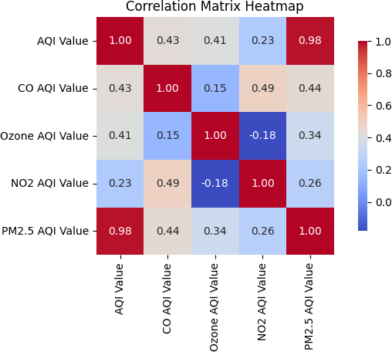

Observation from the Correlation Matrix:
- Strong positive correlation (0.98) between the AQI Value and the PM2.5 AQI Value, indicates that the overall AQI is highly dependent on and closely related to the PM2.5 AQI component.
- The CO AQI Value (0.43) and Ozone AQI Value (0.41) both exhibit moderate positive correlations with the AQI Value.
- The NO2 AQI Value has a relatively weak positive correlation (0.23) with the AQI Value.
- The Ozone AQI Value and NO2 AQI Value has a weak negative correlation (-0.18) which indicates a slight inverse relationship between these two AQI components, where an
increase in one may be associated with a decrease in the other.

+ Outliers shown in box plot:
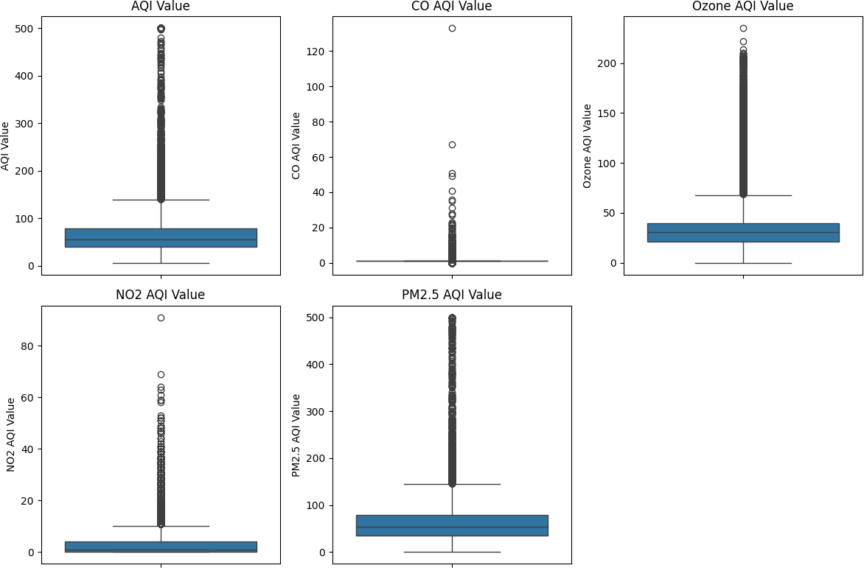

Scatter plot comparing the 4 different pollutants with AQI Value and Key Pattern
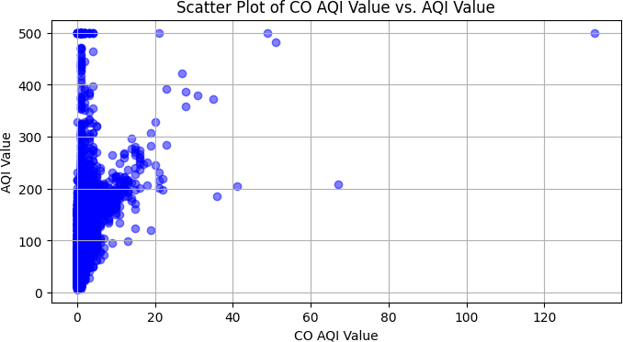

  - Non-linear relationship: The scatter plot exhibits a non-linear relationship between CO AQI Value and AQI Value.
  - Clustered Data: most data points are clustered with low CO AQI Value and AQI Values.
  - Outliers: The plot shows several outlier data points with much higher CO AQI Value and AQI Value compared to the main clustered.

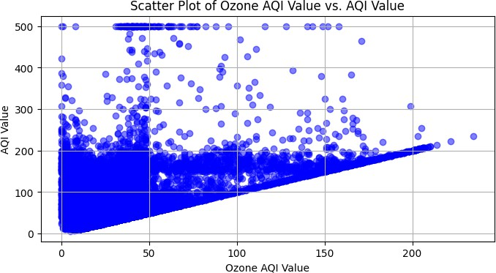

  - Positive Correlation: The scatter plot exhibit a positive relationship between Ozone AQI Value and AQI Value
  - Data Clustering: Most data points clustered at low-to-moderate Ozone AQI Values and AQI Values
  - Outliers: several outlier points have much higher Ozone AQI and AQI Values.

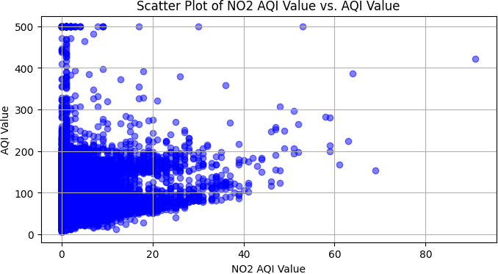

  - Positive correlation: NO2 AQI Value increases with AQI Value, but it is non-linear.
  - Data Clustering: most points cluster in the lower left, indicating low to moderate values.
  - Outliers: several points show significantly higher NO2 and AQI Values
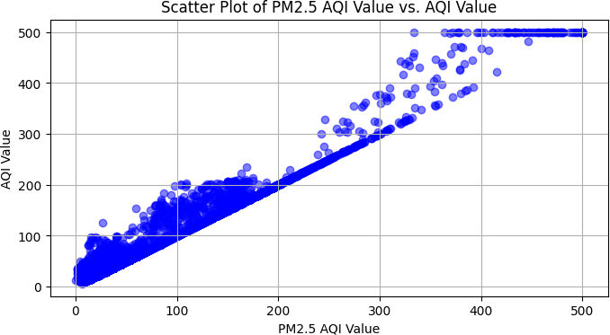
  - The relationship is not perfectly linear.

  - Strong positive linear relationship between PM2.5 AQI and the overall AQI, but it is not perfectly linear.
  - This suggests that PM2.5 is a major contributor to the overall AQI

- Square root transformations were applied to all pollutant-specific AQI values due to the
observed right skewness (positive skew) and the presence of long tails in the data distributions. This transformation aims to achieve a more symmetric distribution, improving the suitability of the data for subsequent analyses.

Histogram of AQI Value and Four Pollutants Before Square Root Transformation
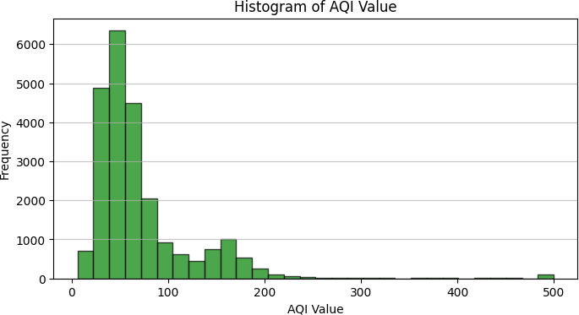
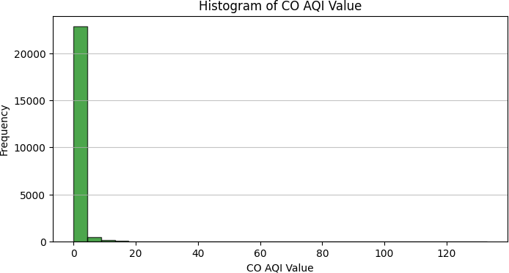

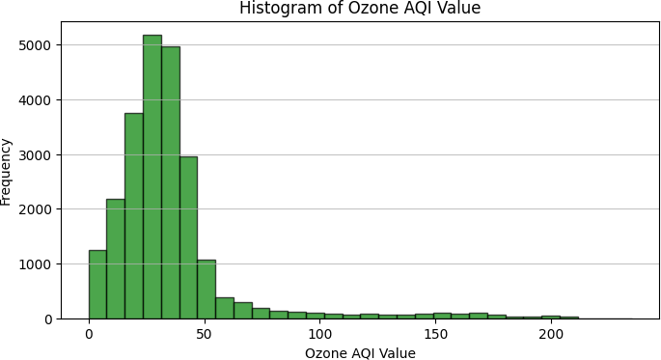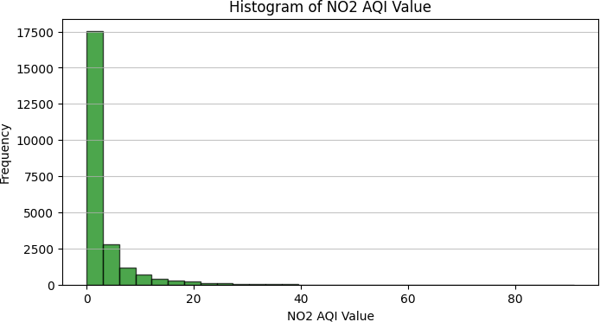
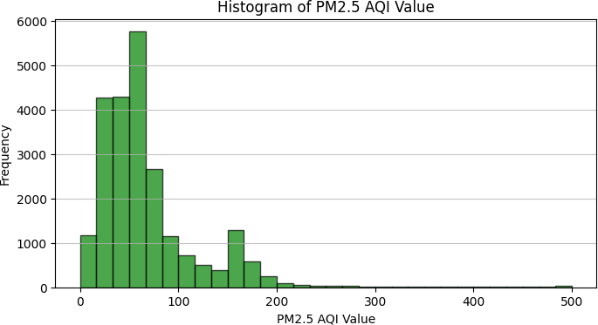

Histogram of AQI Value and Four Pollutants After Square Root Transformation + Key Pattern
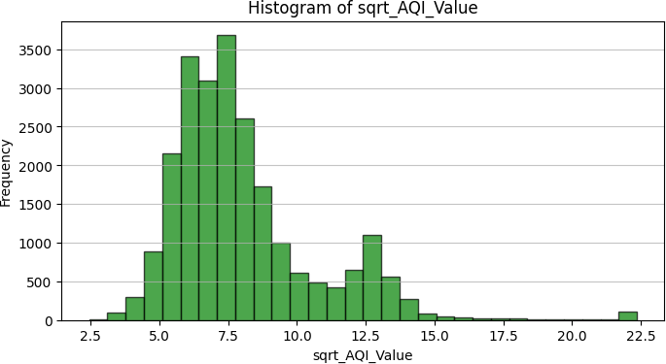

  - Unimodal Distribution: there is one main peak in the data.
  - Right skewness: higher values are less common but go further out.
  - Presence of Outliers: there are some unusually high values that stand out.

  - Value concentration: most data points are grouped together in a specific range.

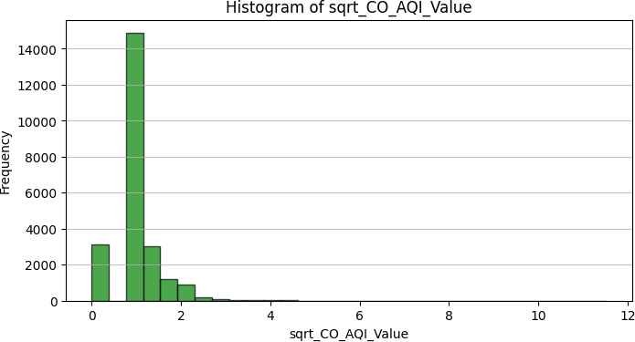
  - Unimodal distribution: there is a single, clear peak indicating unimodal distribution of the square root transformed values.
  - The distribution is positively skewed, with the majority of the values concentrated on the lower end and a longer tail towards higher values.
  - Outliers: the histogram does not show any extreme outliers values, suggesting the square root transformation has successfully addressed and normalized the outliers.

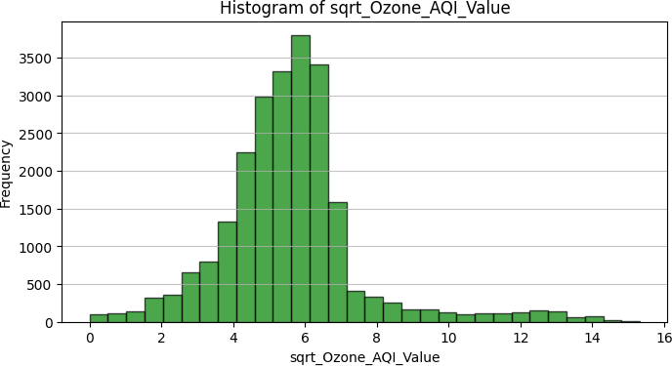

  - The distribution has a single, distinct peak, indicating a dominant mode or central tendency in the data.
  - The distribution is slightly skewed to the right, with a longer tail on the right side of the peak.

  - The majority of the values are concentrated between 4 and 10 on the x-axis, with the peak occurring around 6-8.
  - There are a small number of observations with values less than 2 on the x-axis which consider that they mostly fall under the ‘good’ air quality category.

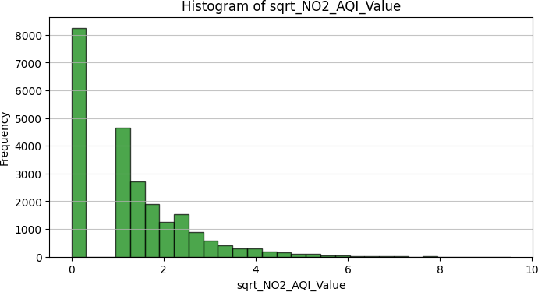

  - There are two distinct peaks in the distribution, indicating the presence of two dominant modes or central tendencies in the data.
  - The first and taller peak is centered around a sqrt_NO2_AQI_Value of 0, suggesting a significant number of observations with very low NO2 AQI values.
  - The second, smaller peak is centered around a sqrt_NO2_AQI_Value of approximately 2, indicating another concentration of observations with moderately low NO2 AQI Values.

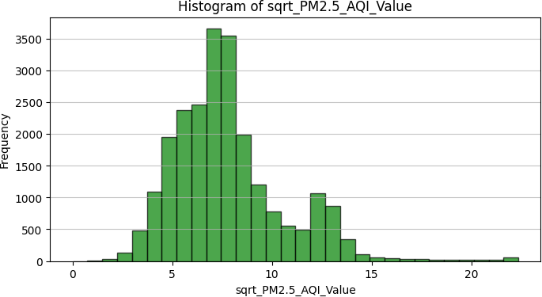

- The distribution has a single, prominent peak.

- The majority of the observations are considered around the peak, which is centered around a sqrt_PM2.5_AQI_Value of approximately.
- There is a gradual decline in frequency on both sides of the peak, with fewer observations at the lower and higher ends of the range.
- The distribution appears to be slightly skewed to the right, with a longer tail on the right side of the peak.

- By using histograms to compare the AQI Value and the 4 pollutants before and after square root transformation, we observe a notable reduction in value. For example, the
original AQI value reaches as high as 500, while the square root transformation reduces this maximum to just 22.5. This represents a significant change in the data.

+ Skewness and Kurtosis Value Before Square root transformation

Skewness | 3.28870236 | 23.08275641 | 3.79338501 | 2.82308193 | 3.10155209
Kurtosis | 17.56600847 | 1289.07419011 | 22.42844499 | 13.61930448 | 12.12033405

+ Skewness and Kurtosis Value After Square root transformation

Skewness | 1.61961786 | 1.03726522 | 1.09377631 | 1.17034284 | 1.21762769
Kurtosis | 4.10728112 | 12.50180166 | 1.4580802 | 2.49693883 | 4.07886475

- Anomalies
Anomalies were still kept in the dataset since when removing it along with the outliers, it has led to a significant loss and insight of valuable insights.

+ Anomalies identified in Numeric Columns before and after Square root transformation using the Interquartile Range (IQR):

Columns | AQI Value | CO AQI | Ozone AQI | NO2 AQI | PM2.5 AQI

 |  | Value | Value | Value | Value
Before Transformation | 272 | 266 | 752 | 596 | 288
After Transformation | 237 | 200 | 625 | 273 | 228

Model Development:
- Choice of models: Polynomial Regression
  - Rationale:
    - Correlation scatter plots show the relationships between the pollutants (CO, Ozone, NO2, PM2.5) and the air quality index (AQI) are positive but not straight lines. Polynomial regression can effectively capture these
non-linear relationships in the data.
    - Using polynomial regression allows for the analysis of how multiple pollutants work together and affect AQI and provide a better understanding.
    - Initial tests, including comparison of Mean Squared Error (MSE) across different models, indicate that polynomial regression yields significantly lower MSE values compared to both simple linear regression and multiple linear regression, demonstrating its superior predictive performance.

  - Polynomial Regression was used to test two different scenarios to evaluate its performance comprehensively.
- Square root transformation: the dependent (AQI) and independent (pollutant concentrations) variables were square root transformed to reduce skewness and stabilize variance.
- Original Data: the original, untransformed data was used to observe the model’s behavior without preprocessing.

- Details on model training, validation and testing processes
- Feature Selection:
Original Data:

  - CO AQI Value
  - Ozone AQI Value
  - NO2 AQI Value
  - PM2.5 AQI Value

Transformed Data:
  - sqrt_CO_AQI_Value
  - sqrt_Ozone_AQI_Value
  - sqrt_NO2_AQI_Value
  - sqrt_PM2.5_AQI_Value

- The target variable chosen is the AQI Value, representing the air quality index we aim to predict.

- The dataset was split into 70% training and 30% testing.
  - Training Set (70%): used to train the model.
  - Test Set (30%): used to evaluate the final model’s performance on unseen data.
  - The train-test split was performed first, and if a validation set were to be created, the remaining 30% could be further split into 50% for validation and 50% for testing. However, in the provided code, no validation set was explicitly created; the focus was solely on training and testing.
  - After the split, the polynomial regression models were trained on the training set for various polynomial degrees (1 to 4), and performance metrics such as RMSE and R² were calculated for both the training and test sets to assess the models' effectiveness.

+ While building the model, the square root transformation was applied again to enhance model performance. While a single transformation yielded satisfactory results, the additional application significantly improved the following metrics:
  - RMSE: Decreased, indicating enhanced predictive accuracy.

  - R²: Increased, reflecting a greater proportion of variance explained by the model.

- Hyperparameter Tuning: The degree of the polynomial was selected through grid search and cross-validation, with degrees ranging from 1 to 4. We selected the degree that provided the best trade-off between fit and overfitting, using the validation set for hyperparameter tuning.

- Model optimization: cross validation was performed to evaluate the stability of the model’s performance across different data splits and reduce the risk of overfitting to the training data.

Results and Evaluation
+ Evaluation Metrics:
- Root Mean Squared Error (RMSE): Measure the average magnitude of error in the model’s prediction. A lower RMSE indicates a better fit.
- 𝑅 (Coefficient of Determination): Indicates the proportion of the variance in the target variable that is explained by the model. A higher 2 indicates a better fit.
2
𝑅

Performance with Original Data (No Transformation)

Polynomial Degree | RMSE | 2  𝑅
Degree 1 | 8.742 | 0.975
Degree 2 | 6.993 | 0.984
Degree 3 | 4.572 | 0.993
Degree 4 | 4.443 | 0.994

Findings: As the polynomial degree increased, the model’s RMSE decreased, and R² improved, indicating a better fit. However, Degree 4 shows the lowest RMSE and the highest R², suggesting that higher-degree polynomials might be overfitting the data.

Performance with Two Squared Root Transformed Applied

Polynomial Degree | RMSE | 2  𝑅
Degree 1 | 0.118 | 0.927
Degree 2 | 0.076 | 0.970
Degree 3 | 0.051 | 0.986
Degree 4 | 0.040 | 0.992

Findings:
- The square root transformation significantly reduces the RMSE for all degrees, indicating a better overall fit compared to the original data.
- Degree 4 provided the best performance with an RMSE of 0.040 and 2 of 0.992, but like the original data, this might still indicate overfitting.
𝑅

+ Overfitting Check

- Original Data:

Polynomial Degree | Train RMSE | Train 2  𝑅 | Test RMSE | Test 2  𝑅 | Cross Validation RMSE | CV  Standard Deviation
Degree 1 | 9.026 | 0.974 | 8.742 | 0.975 | 8.941 | ± 0.447
Degree 2 | 7.180 | 0.984 | 6.993 | 0.984 | 7.219 | ± 0.361
Degree 3 | 4.596 | 0.993 | 4.572 | 0.993 | 8.310 | ± 4.350
Degree 4 | 4.059 | 0.995 | 4.443 | 0.994 | 31.916 | ± 33.058

Findings:
As the polynomial degree increased, the model’s RMSE decreased, and 𝑅2
improved, indicating a better fit. However, Degree 4 shows the lowest RMSE and

the highest 2, suggesting that higher-degree polynomials might be overfitting the data.
𝑅

- Square root transformation applied twice to the data

Polynomial Degree | Train RMSE | Train 2  𝑅 | Test RMSE | Test 2  𝑅 | Cross Validation RMSE | CV  Standard Deviation
Degree 1 | 0.118 | 0.927 | 0.118 | 0.927 | 0.118 | ± 0.003
Degree 2 | 0.075 | 0.970 | 0.076 | 0.970 | 0.075 | ± 0.001
Degree 3 | 0.045 | 0.990 | 0.051 | 0.986 | 0.048 | ± 0.003
Degree 4 | 0.034 | 0.994 | 0.040 | 0.992 | 0.037 | ± 0.004

Findings:
The application of square root transformation significantly reduced RMSE across all polynomial degree, while 2 values remained high, indicating a strong fit. This resulted in consistently low training and testing RMSE values.
𝑅

Conclusion
+ Summarize key findings and their implications
  - Polynomial regression with degree 4 provided the best performance particularly with square root-transformed data. This approach captures the non-linear relationship between pollutants and AQI, offering highly accurate predictions.
  - The square root transformation improved model performance by stabilizing variance and reducing the influence of extreme values in the data.
  - The polynomial regression model showed good generalization performance, with minimal overfitting, especially when combined with cross-validation.
  - PM2.5 is identified as the pollutant most closely related to the AQI Value, underscoring its significance in air quality assessments.

+ Limitations of the Analysis:

  - Overfitting Risk: While polynomial regression performed well, higher-degree polynomials are prone to overfitting. In some cases, the model might perform excellently on training data but not generalize well to unseen data.
  - Data Preprocessing: The square root transformation improved performance but may not always be applicable or necessary for other datasets. Further research could explore other transformations or feature engineering techniques.
  - Model Complexity: As the polynomial degree increased, the model became more complex and less interpretable, which could be a limitation in applications where model transparency is important.

+ Future Research and Improvement:
- Experimenting with Other Models: explore more complex models such as Random Forests or Gradient Boosting Machines for better handling of non-linearities.

References:
Dataset used:
https://www.kaggle.com/datasets/hasibalmuzdadid/global-air-pollution-dataset/data

Air Quality Index (AQI) Basics
https://www.airnow.gov/aqi/aqi-basics/#:~:text=The%20higher%20the%20AQI%20value,300%2 0represents%20hazardous%20air%20quality.

Implementation of Polynomial Regression
https://www.geeksforgeeks.org/python-implementation-of-polynomial-regression/

Data Visualization Guidance
https://www.datacamp.com/blog/what-is-data-visualization-a-guide-for-data-scientists?utm_sour ce=google&utm_medium=paid_search&utm_campaignid=19589720824&utm_adgroupid=1529 84013574&utm_device=c&utm_keyword=&utm_matchtype=&utm_network=g&utm_adpostion
=&utm_creative=720362650489&utm_targetid=dsa-2222697812118&utm_loc_interest_ms=&ut m_loc_physical_ms=9198350&utm_content=DSA~blog~Data-Visualization&utm_campaign=2

30119_1-sea~dsa~tofu_2-b2c_3-row-p2_4-prc_5-na_6-na_7-le_8-pdsh-go_9-nb-e_10-na_11-na- bfcm24&gad_source=1&gclid=CjwKCAiAl4a6BhBqEiwAqvrqusFrZ-alyPX8EILpfcp5fZk2vn6 BqsZXcCtu87XhEzdKo0HrZTUshhoCnYwQAvD_BwE

Libraries used:
Pandas NumPy Matplotlib Seaborn
Scikit-learn: Clustering Scikit-learn: Preprocessing

Appendix:
Brief description about the 4 pollutants in the dataset:

- Nitrogen Dioxide (NO2): A harmful gas primarily from vehicle and industrial emissions.
Short-term exposure can worsen respiratory conditions, while long-term exposure can contribute to respiratory diseases, especially for vulnerable groups like children, the elderly, and those with asthma.
- Ozone (O3): A harmful gas formed from pollutants in sunlight. Ground-level ozone can cause respiratory problems, reduce lung function, and damage vegetation.
- Carbon Monoxide (CO): A colorless, odorless gas often emitted from vehicles and indoor sources like gas stoves and heaters. Inhalation can reduce oxygen transport in the blood, leading to symptoms like dizziness, confusion, and in severe cases, death.
- Particulate Matter (PM2.5 and PM10): Tiny particles in the air that can penetrate deep into the lungs, causing serious health problems like heart and lung disease. They are classified as carcinogens.

- Provide additional figures, tables, or code snippets that support the analysis.

Levels of Concern | Values of Index | Description of Air Quality

Good | 0 to 50 | Air quality is satisfactory and air pollution poses little or no risks.
Moderate | 51 to 100 | Air quality is acceptable. However, there may be a risk for  some people, particularly those who are usually sensitive to air pollution.
Unhealthy for  Sensitive Groups | 101 to 150 | Members of sensitive groups may experience health effects, and members of sensitive groups may experience more serious health effects.
Unhealthy | 151 to 200 | Some members of the general public may experience health effects; members of sensitive groups may experience more serious health effects.
Very Unhealthy | 201 to 300 | Health alerts: The risk of health effects is increased for everyone.
Hazardous | 301 and higher | Health warning of emergency conditions: everyone is more likely to be affected.

- Table to show descriptive statistic of the AQI Value and the 4 pollutants after square root transformation

 | Sqrt AQI Value | Sqrt CO AQI Value | Sqrt Ozone AQI Value | Sqrt NO2 AQI Value | Sqrt PM2.5 AQI  Value
Count | 23463.0000000 | 23463.000000 | 23463.000000 | 23463.000000 | 23463.000000
Mean | 8.056338 | 1.031541 | 5.594453 | 1.241244 | 7.786324
Standard Deviation | 2.665817 | 0.551637 | 1.973822 | 1.233982 | 2.809494
Minimum | 2.449490 | 0.000000 | 0.000000 | 0.000000 | 0.000000
25% | 6.244998 | 1.000000 | 4.582576 | 0.000000 | 5.916080
50% | 7.416198 | 1.000000 | 5.567764 | 1.000000 | 7.348469
75% | 8.888194 | 1.000000 | 6.324555 | 2.000000 | 8.888194
Maximum | 22.360680 | 11.532563 | 15.329710 | 9.539392 | 22.360680

- Outliers Identified in Numeric Columns after Square Root Transformation using the Interquartile Range (IQR):
. sqrt_AQI_Value: 1506
. sqrt_CO_AQI_Value: 8596
. sqrt_Ozone_AQI_Value: 1758
. sqrt_NO2_AQI_Value: 241
. sqrt_PM2,5_AQI_Value: 796

+ Performance with One Square Root Transformation applied

Polynomial Degree | RMSE | 2  𝑅
Degree 1 | 0.568 | 0.954
Degree 2 | 0.382 | 0.979
Degree 3 | 0.231 | 0.992
Degree 4 | 0.192 | 0.995

Finding: RMSE decreases from 0.568 (Degree 1) to 0.192 (Degree 4), while 2 increases from 0.954 to 0.995, indicating a better fit with higher degrees.
𝑅

+ Overfitting check with one square root transformation

Polynomial Degree | Train RMSE | Train 2  𝑅 | Test RMSE | Test 2  𝑅 | Cross Validation RMSE | CV  Standard Deviation
Degree 1 | 9.026 | 0.974 | 8.742 | 0.975 | 8.941 | ± 0.447
Degree 2 | 7.180 | 0.984 | 6.993 | 0.984 | 7.219 | ± 0.361
Degree 3 | 4.596 | 0.993 | 4.572 | 0.993 | 8.310 | ± 4.350
Degree 4 | 4.059 | 0.995 | 4,443 | 0.994 | 31.916 | ± 33.058

Finding: Degrees 1 and 2 show good generalization with closely aligned train and test RMSE. However, Degree 3 indicates potential overfitting, and Degree 4 exhibits significant overfitting, indicated by a high cross-validated RMSE of 31.916 and large standard deviation (± 33.058).

Google collab link used throughout this project: https://colab.research.google.com/drive/1C5ccsUsecUqbWhdx-f4Z986wp7Bxuu3b?usp=sharing

